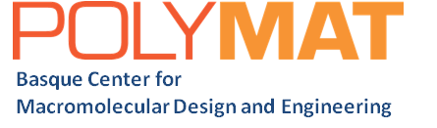

**PhD Fellowship**

A PhD Fellowship is available in the Polymers for Health division at the Basque Center for Macromolecular Design and Engineering, POLYMAT Fundazioa ([www.polymat.eu](http://www.polymat.eu)).

**Polyphenols-Based Eutectogels for Biomedical Applications**

We offer a highly multidisciplinary project that combines research involving physical chemistry, materials science, and polymer science & engineering. The project considers the fabrication of therapeutic eutectogels based on deep eutectic solvents and low-transition-temperature mixtures obtained from natural polyphenols.

The project will be conducted at **POLYMAT**, a vibrant multidisciplinary and international research institute in Bilbao and San Sebastian, Spain. The Institute offers excellent working conditions and is well-equipped with instrumentation and facilities.

**Required qualifications and experience.**

Applicants must have a BSc and MSc in Chemistry, Chemical Engineering, Materials Engineering, Biotechnology, or a related discipline. The candidate is expected to work in a multidisciplinary and international environment. A good command of written and spoken English is a must.

Applications should be addressed to Dr. Matías Picchio and sent via email in one single PDF to [matias.picchio@polymat.eu](mailto:matias.picchio@polymat.eu) before 15.10.2024, including:

1. a cover letter highlighting their interest in the position.
2. curriculum vitae.
3. academic record.
4. a short description of previous research (1-2 Pages).
5. the names and contact addresses (email) of two academic referees.

POLYMAT has obtained the ‘HR Excellence in Research award‘. The award reflects our commitment to continuously improving our human resource policies in line with the European Charter for Researchers, the Code of Conduct for the Recruitment of Researchers, and our commitment to achieving fair and transparent recruitment and appraisal procedures.